**Bad Certificate Fix**

**NOTES:**

* **Technology is ever changing so the below instructions may be slightly different than what steps you will encounter.**
* **Use the most updated version available.**
* **Visit** [**http://iase.disa.mil/pki-pke**](http://iase.disa.mil/pki-pke)

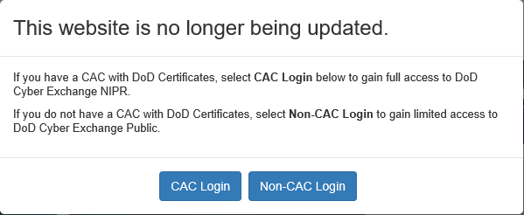

* **Select CAC Login**



* **Click in the search area and enter “FBCA_CrossCert_Remover”**

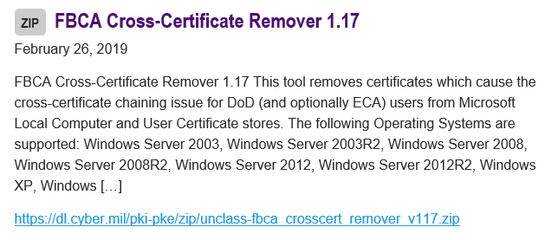

* Select the hyperlink of FBCA Cross-Certificate Remover 1.17 or <https://dl.cyber.mil/pki-pke/zip/unclass-fbca_crosscert_remover_v117.zip>





* Click on Open



* Double click on FBCA_Crosscert_remover_v###



* Click Extract all



* Select Extract



* Double click on red X FBCA_Crosscert_remover_v###

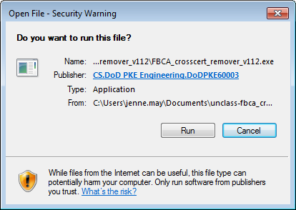

* Select Run ***if the first box appears; if the next two black boxes appear wait for information to populate in the box and once you are prompted to hit ENTER, hit Enter on your keyboard; if the screen populates twice, once you see ENTER again, hit Enter on your keyboard; when the screens disappear, you are done and can proceed to DCPDS.
* ***If not, there may be a blue box that opens where the only option is to Close, instead, select More Info, then Run Anyway