**--- Performance Appraisals ---**

**Quick Steps for How to Copy the Old PA and Start the New**

*As of 9 October 2018*

**WEBSITE: MyBiz+,** [**https://compo.dcpds.cpms.osd.mil/**](https://compo.dcpds.cpms.osd.mil/)

**Step 1: Print/save all previous PAs.**

* **Select MyPerformance under Key Services (for your own appraisal)**

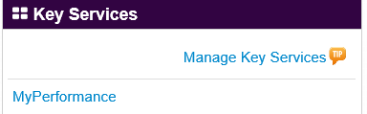

* **Select Show Completed Plans/Appraisals from the MyPerformance Main Page:**

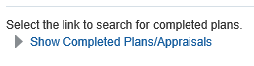

* **Select NG Performance Evaluation from the dropdown menu and select Find:**

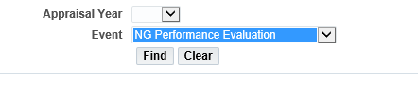

* + **Do NOT click anything else (Be patient, this will take a minute or so to populate.)**
  + **Leave the year blank to pull all completed PAs.**
* 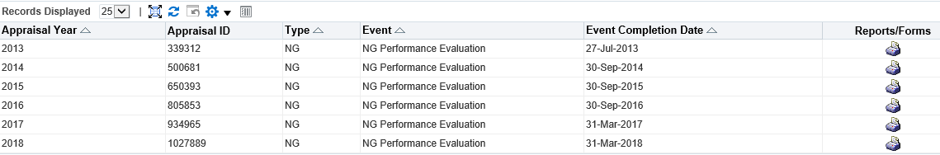**Double-click the printer icon located to the right of each Appraisal Year and print/save/copy your completed PAs.**

**Step 2: Create Plan in new system.**

* From the MyPerformance Main Page, select DoD Performance Management Appraisal Program from the Create New Plan dropdown and Go.

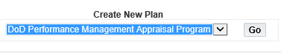

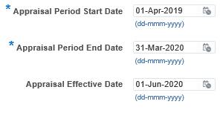

* Type the last name, first name and WAIT a few seconds to select the correct name from the dropdown menu. ***If the RO or HLR is a II or Jr the format may be last name, II, first name.



* If this is your first time using the DoD Performance Management Appraisal Program, you will not be able to copy from an existing plan, you must select Build New Plan.



* If you are in the same position title and pay grade as your last completed PA, you can select Build New Plan, pull up a copy of your last completed PA (ie .pdf, .doc, etc) and copy and paste information from the old plan into the new, updating objectives as necessary. If your position title and pay grade have changed, you will need to ensure your Job Objectives are updated to match your Position Description.
* 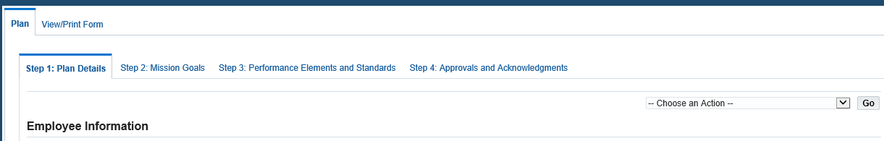Progress through the steps of building the Plan, complete the Interim Review (as appropriate) and then the Appraisal.